CSE2003- DSA PROJECT REPORT

(J Component)

submitted by

**ARYA ABROL (18BCE0691)**

**Software information:**

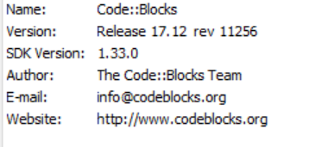

**Instructions to operate the programme:**

1. Install Code blocks in your computer
2. Build and Compile the source code given along with.
3. A menu window will appear, enter the stated options to execute the desirable operations:
4. Add music
5. Delete Music
6. Update Music
7. Display Music
8. Search for Music
9. Exit
10. Press 6 to exit the programme